DataOps Suite Hardware Requirements & Architecture

Prepared by

datagaps

http://www.datagaps.com

http://help.datagaps.com

http://datagaps.freshdesk.com
Contact
contact@datagaps.com

Table of Contents
Purpose of the DOCUMENT 1
ETL Validator 2
ETL Validator Architecture 2
ETL Validator Client 2
ETL Validator Server 2
Repository and Work Schema (Database Users) 3

Purpose of the DOCUMENT
This document explains the architecture, hardware requirements and pre-requisites for deploying DataOps Suite.

ETL Validator

DataOps Suite Architecture
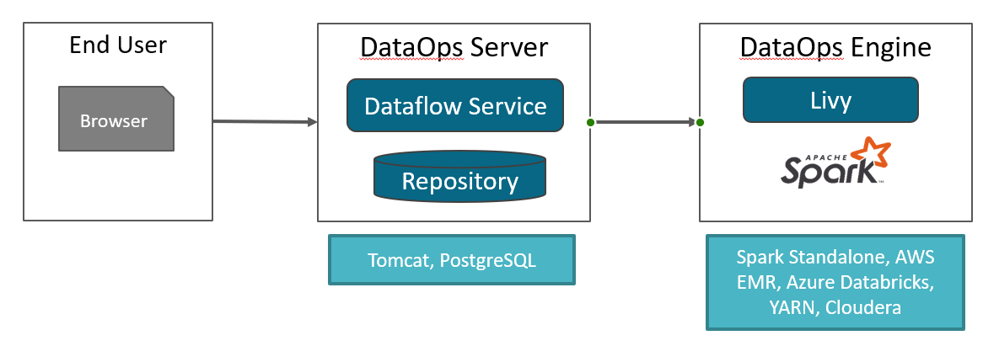

DataOps Server
DataOps Server is a java-based service deployed in Apache Tomcat. Both Repository and java services can be deployed in the same server machine.
- Operating System
  - Linux, Windows 2012 or later
- Software
  - Open JDK 11
  - Tomcat 9 or later
  - PostgreSQL 12.x (or equivalent RDS can be used)
- Hardware
  - Processor
    - Recommended: 8 Cores
  - Memory (RAM)
    - Recommended: 16 GB
  - Hard drive
    - Minimum: 200 GB SSD
    - Recommended: RAID.

DataOps Engine

Standalone Server
DataOps Engine consists of Apache Livy and Apache Spark.
- Operating System
  - Linux or Windows 2012 or later
- Software
  - Open JDK 8/11
  - Apache Livy 0.7
  - Apache Spark 3.0.1
  - Apache Hadoop 3.2.1
- Hardware
  - Processor
    - Minimum: 16 Cores
    - Recommended: 32 Cores
  - Memory (RAM)
    - Minimum: 64 GB RAM
    - Recommended: 128 GB (ECC) or more
  - Hard Disk
    - Minimum: 1TB GB SSD
    - Recommended: RAID. Size is dependent on the volume of data being tested. Typically, the size needed is 2.5 times the volume of data being compared.
  - Network
    - Minimum: 1 Gb
    - Recommended: 10 Gb

AWS EMR
DataOps can use AWS EMR as the engine for executing dataflows.
- AWS EMR
  - Certified with EMR Version 6.2

