BI Validator Hardware Requirements & Architecture

Prepared by

datagaps

http://www.datagaps.com

http://help.datagaps.com

http://datagaps.freshdesk.com
Contact
contact@datagaps.com

Table of Contents
Purpose of the DOCUMENT 1
BI Validator 2
BI Validator Architecture 2
BI Validator Client 2
BI Validator Server 2
BI Validator Repository 3

Purpose of the DOCUMENT
This document explains the architecture, hardware requirements and pre-requisites for deploying BI Validator.

BI Validator

BI Validator Architecture
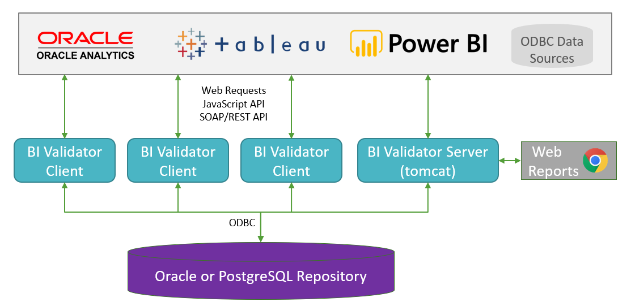

BI Validator Client
BI Validator Desktop is a Windows based thick client.
- Operating System
  - Windows Server 2012 or later (virtual or physical), Windows 10
- Hardware
  - Processor
    - Minimum: 4 Cores
    - Recommended: 8 Cores
  - Memory (RAM)
    - Minimum: 8 GB
    - Recommended: 16 GB or more
  - Hard drive
    - Minimum: 20 GB of hard-disk space
  - Display dimensions:
    - Minimum: 1366x768
    - Recommended: 1920x1080
Note: Stress testing may require additional hardware depending on the number of concurrent users being simulated. The above recommended configuration should be enough for simulating 50 concurrent users.

BI Validator Server
BI Validator Server consists of Reporting and Server archive files that can be deployed on Apache Tomcat.
- Java 1.8 (comes bundled with the BI Validator Server install)
- Tomcat 9 or later (comes bundled with the BI Validator Server install)
- Operating System
  - Windows Server 2012 or later (virtual or physical)
- Hardware
  - Processor
    - Minimum: 8 Cores
    - Recommended: 12 Cores or better
  - Memory (RAM)
    - Minimum: 16 GB RAM
    - Recommended: 32 GB (ECC) or more
  - Hard Disk
    - Minimum: 500 GB SSD
    - Recommended: RAID. Size is dependent on the volume of data being tested.
  - Network
    - Minimum: 1 Gb
    - Recommended: 10 Gb

BI Validator Repository
PostgreSQL : The server/desktop install come with the PostgreSQL 10.3 database.
Oracle : Below privileges are required for the Oracle user hosting BI Validator Repository.
CREATE USER bivalidator IDENTIFIED BY bivalidator;
GRANT CONNECT, RESOURCE, CREATE SESSION, CREATE TABLE, CREATE VIEW, CREATE SEQUENCE, CREATE
PROCEDURE, CREATE TYPE, CREATE SYNONYM TO bivalidator;
ALTER USER bivalidator DEFAULT ROLE NONE;

GRANT CREATE TRIGGER, ALTER ANY TABLE, ALTER ANY PROCEDURE TO bivalidator;

