Configure DGCL on Jenkins

Here we will show you how to setup DGCL build with jenkins that automatically executes your test plans Test Plans and display the results on jenkins console.

Step - 1: Add new Job
Go to the Jenkins dashboard and Click on New Item
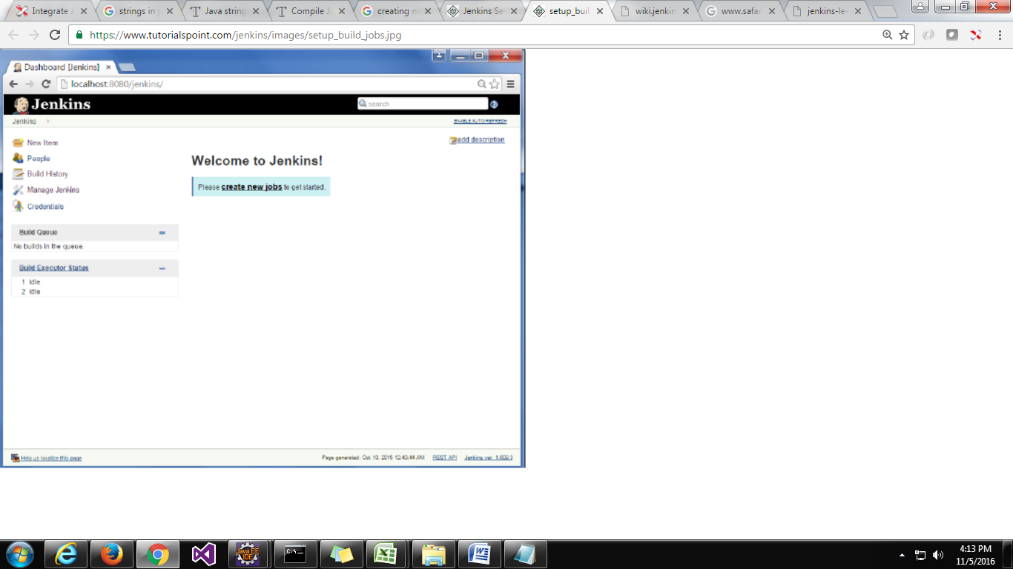

Step 2 − In the next screen, enter the Item name, in this case we have named it BIV_DGCL. Choose the "Freestyle project" option and click "Ok" button.
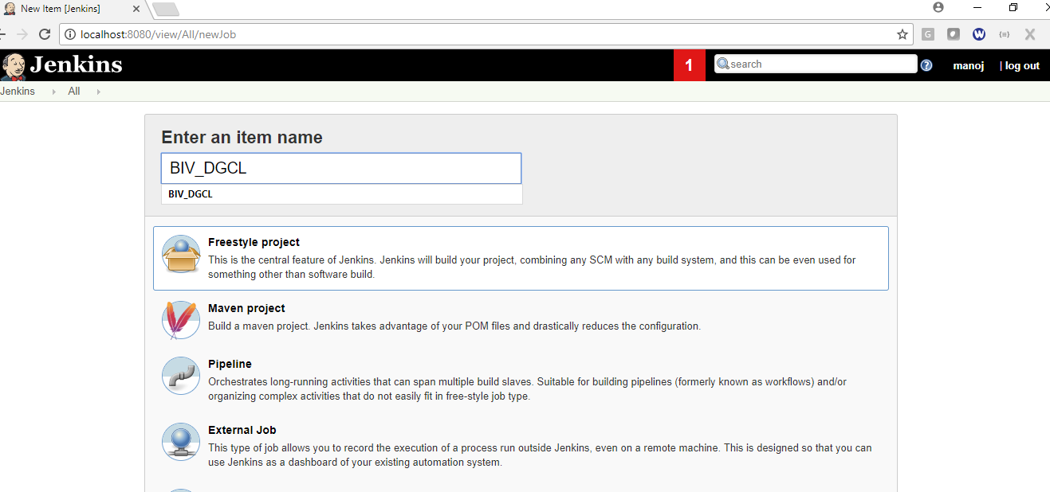

Step 3 − The following screen will come up in which you can specify the details of the job.
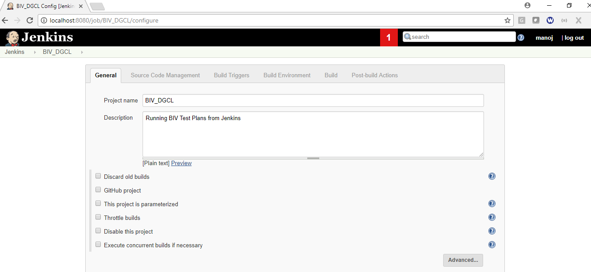
In the description you enter project details to understand. And keep the all check box's uncheck for now.

Step 4 - Configure Source Code Management
We need to specify the location of the files which need to be built.
a) If project files on Local system
If you have build in your local system then you can skip this step and click on apply and save.
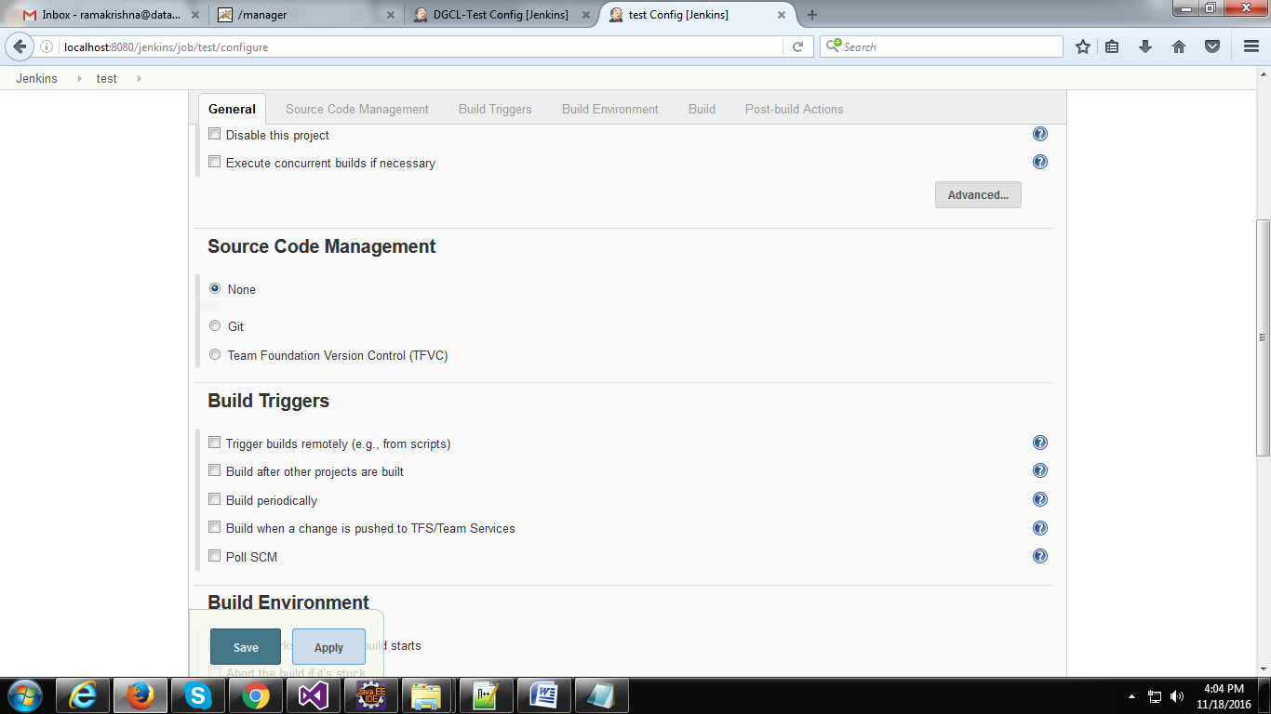
Keep default selection None.

b) If project files on TFS
Start with choosing Team Foundation Version Control (TFVC) as source code management tool.
Enter the following details.
Collection url: https://datagaps.visualstudio.com
project Path: $/Datagaps/BIValidator/DGCL_build
Credentials: For credentials select "manual" from the drop down and enter the TFS credentials. (Here we should enter "Alternate authentication credentials" to connect to TFS and check out the code)
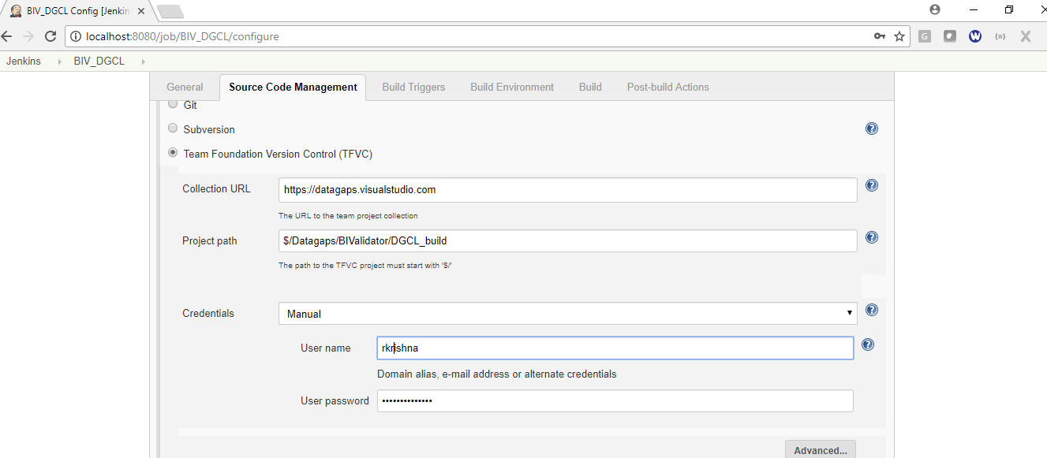

Step 5 − Once saved, you can click on the Build Now option to see if you have successfully defined the job.

Step 6 − Once the build is scheduled, it will run.

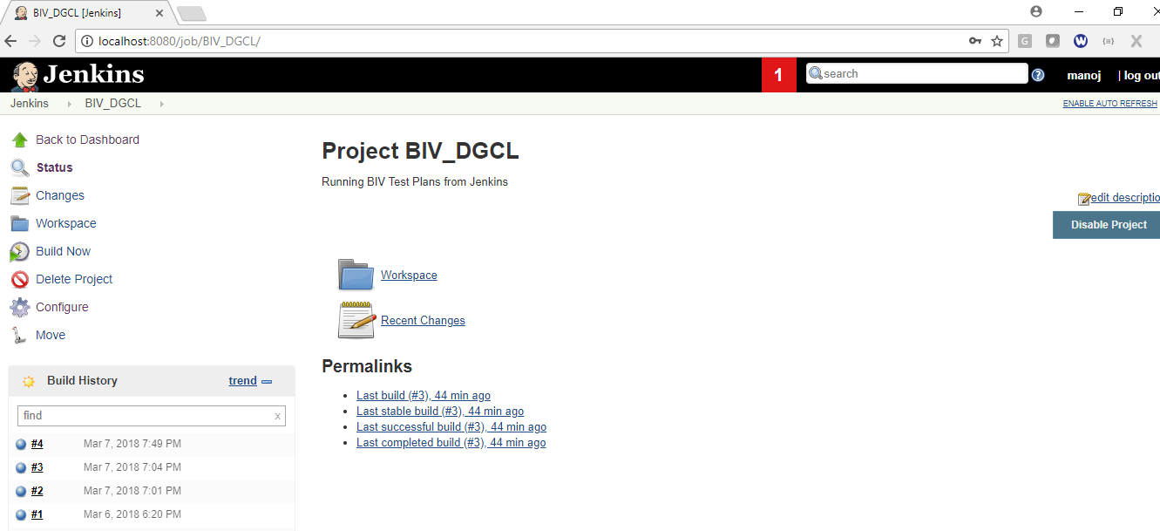

Once build run is successfully completed, then it will create a folder with the project name(BIV_DGCL) in jenkins home folder under workspace.
If you select "TFVC" under source code management then it will check out the project files from TFS and automatically save into your jenkins workspace. You can check the downloaded files bellow folder.
jenkinsHomeDir(C:\Users\DATAGAPS\.jenkins)>> workspace>>BIV_DGCL.

If you select "None" under source code management then it will create empty folder in your jenkins workspace.
jenkinsHomeDir(C:\Users\DATAGAPS\.jenkins)>> workspace>>BIV_DGCL

Now you copy the files lib and BIValidatorTest.jar from your local system and paste it into above folder.

Step 7 - Now back to jenkins and go to project home page now click on configure tab from the left side menu.

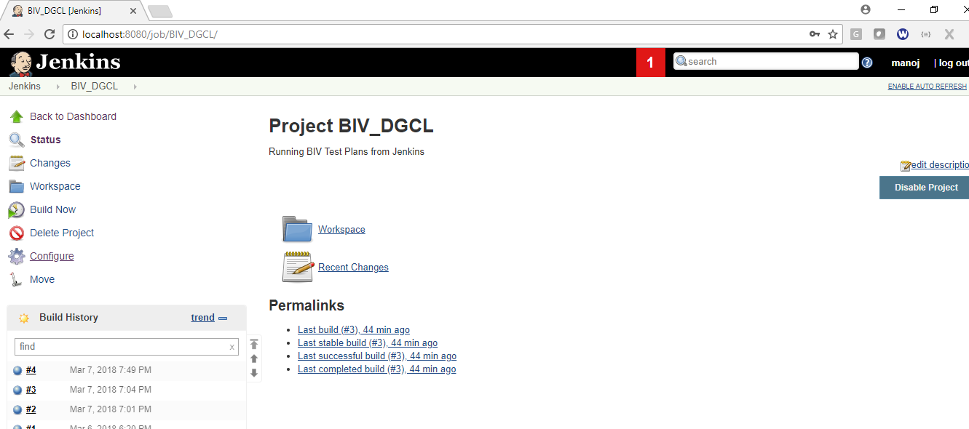

Step 8 - Now go to the build section and select "Execute windows batch command" from the dropdown.

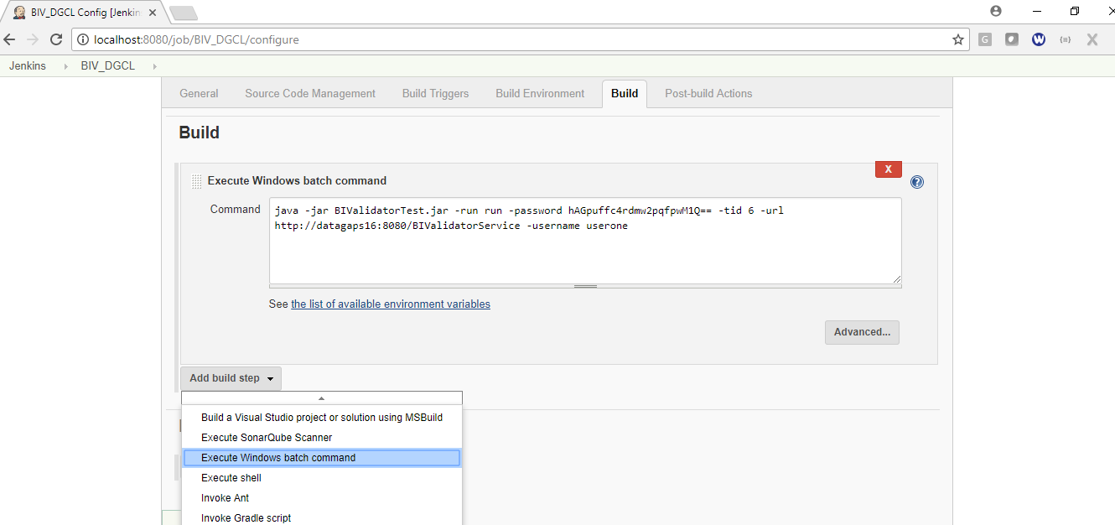

Step 9 - Now enter the command line scripts in the Command box to run Test Paln. Ex: Sample command to run the Test Plan.
java -jar BIValidatorCLI.jar -runTestPlan -username admin -password 9D03kcEhuhOVXi7COmC6Kw== -tid 2 -url http://datagaps16:8080/BIValidatorService

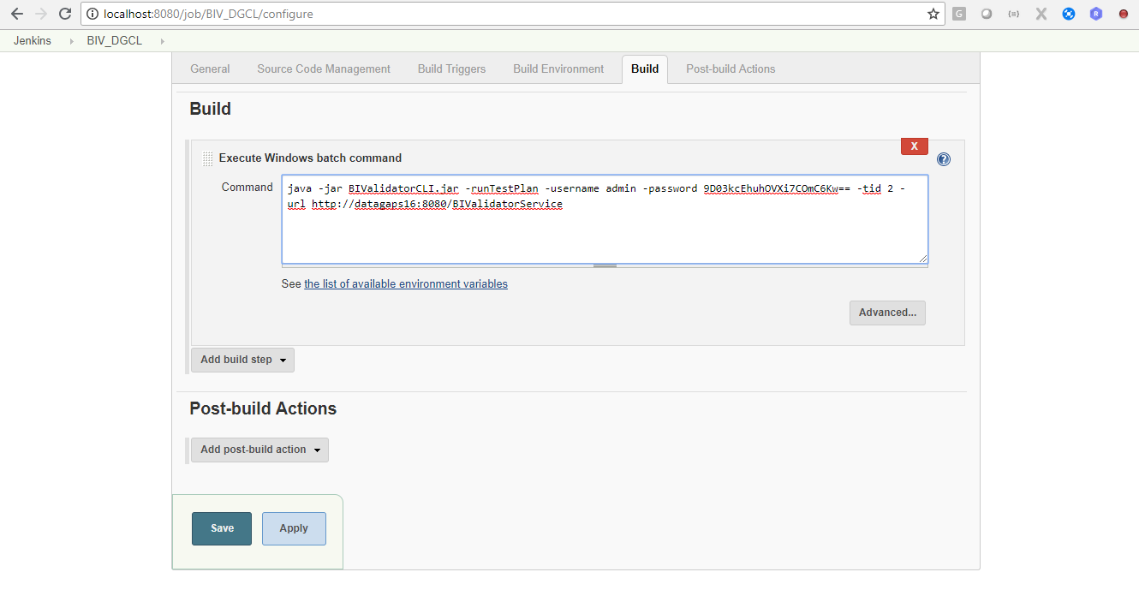

If you want to execute mutliple commands in the same build you can add all commands into the above Command box by seperating with enter key.
Now click on apply & Save.

Step 10 − Once saved, you can click on the Build Now option to see if you have successfully defined the job.

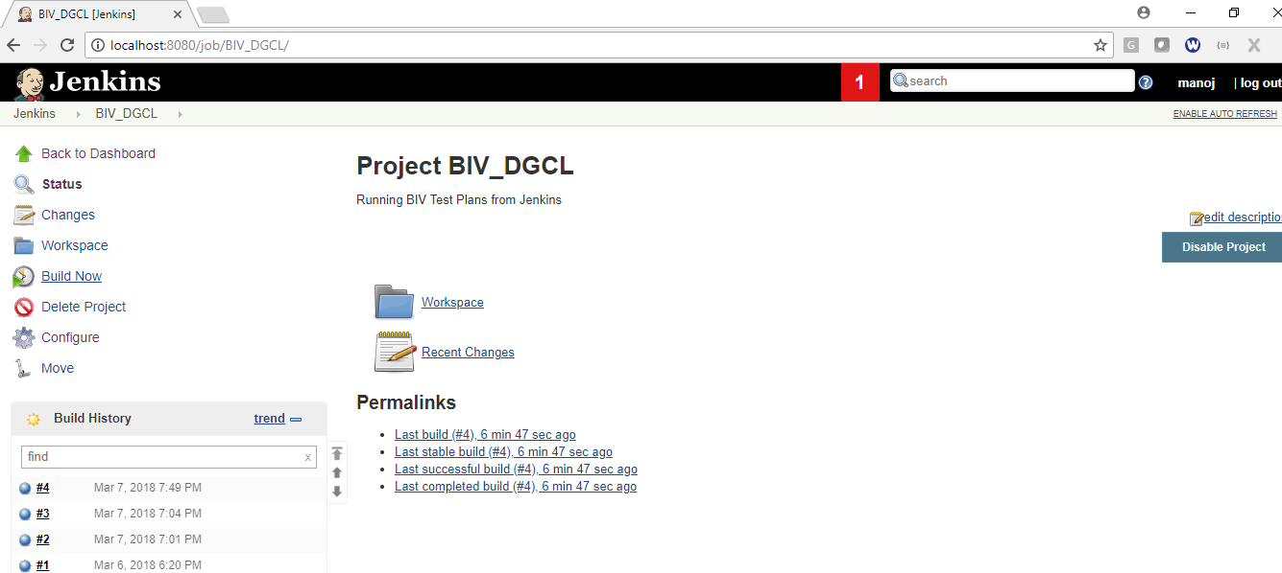

Step 11 − Once the build is completed, a status of the build will show if the build was successful or not. Click on the #4 in the Build history to bring up the details of the build.

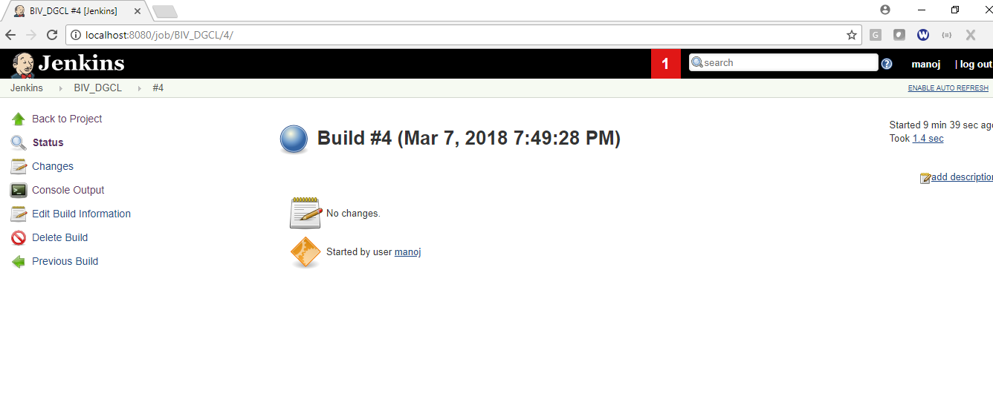

Click the "Console Output" Tab from the left side menu to see the console output.
