Jenkins Documentation
Install Jenkins:
1. Download the latest version of Jenkins from: https://jenkins.io/
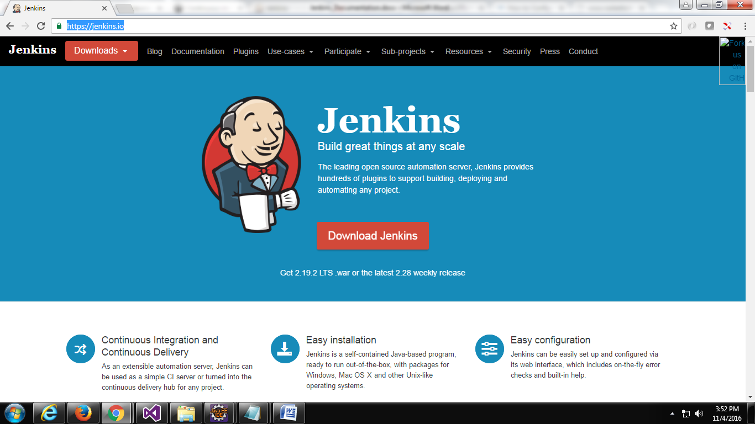

Click on Download jenkins button it will show two releases.1)LTS Release 2)Weekly Release
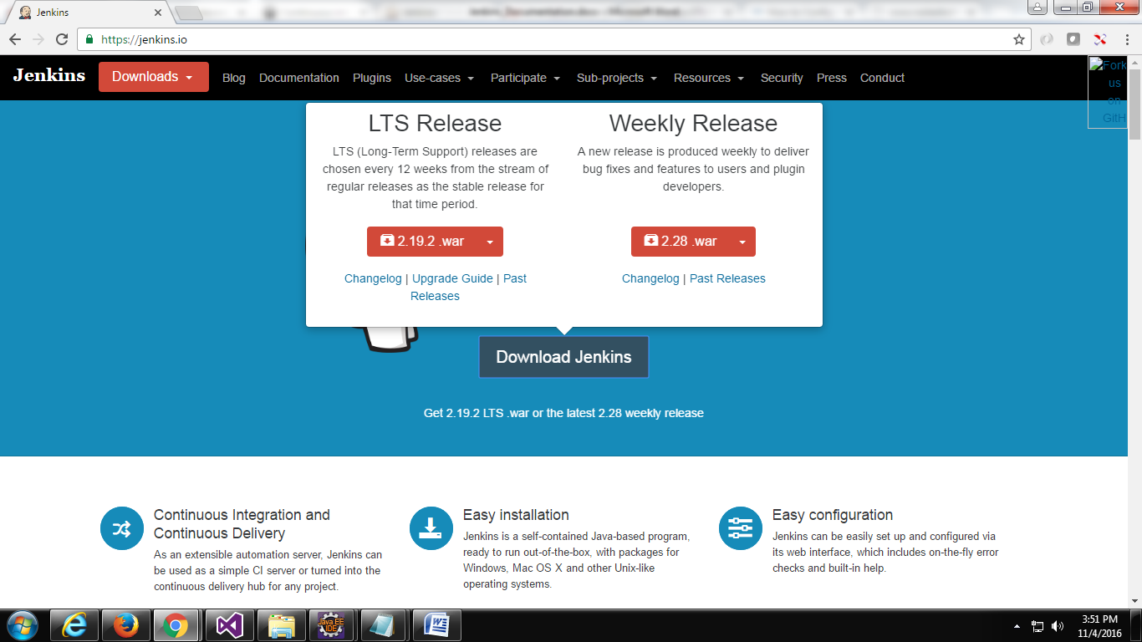
Click on the "2.19.2.war" it will download "jenkins.war" file directly into your systemfrom this file you can start Jenkins directly via the command line with java -jar jenkins*.war.
If you start it locally, you find it running under the following URL: http://localhost:8080/

To run it in your Tomcat server, put the .WAR file into the webapps directory. If you start Tomcat, your Jenkins installation will be available under http://localhost:8080/jenkins.

For OS specific(for windows):
Click on LTS Release dropdown and select Windows and download the Zip file.
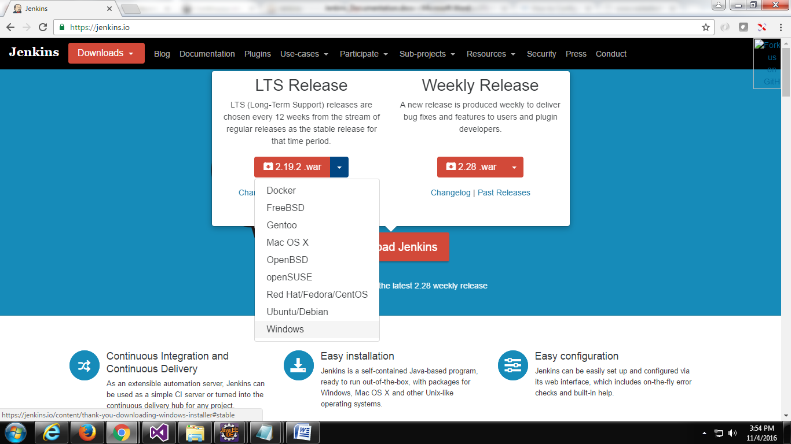

Go to the downloaded folder, extract the setup files from the zip file and run the "jenkins.msi" file
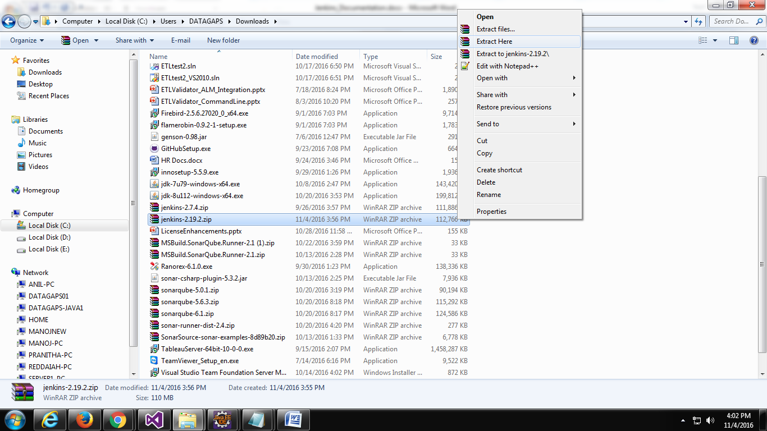

Click on next
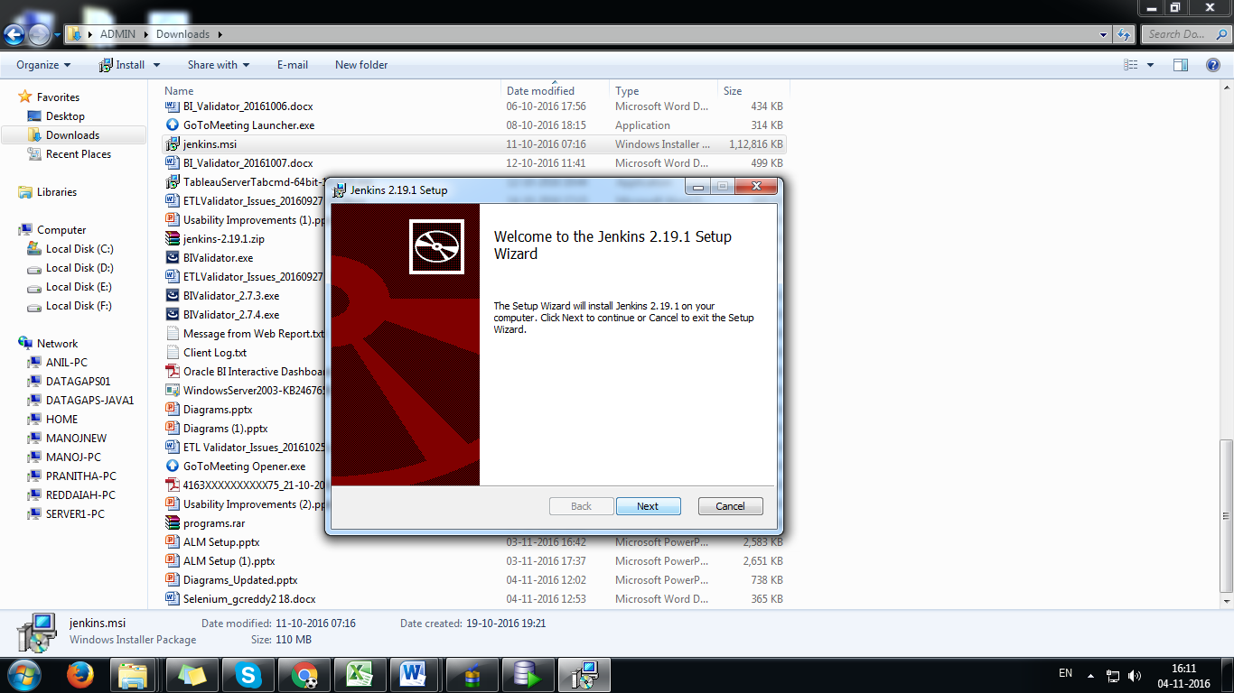

By default it will install under the folder "C:\Program Files (x86)". If you want to change the installation directory you can change by clicking on change button and select the installation directory.
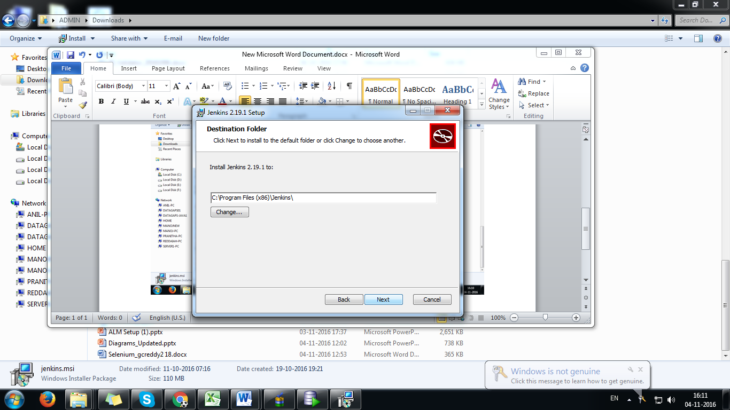

Click on install button.
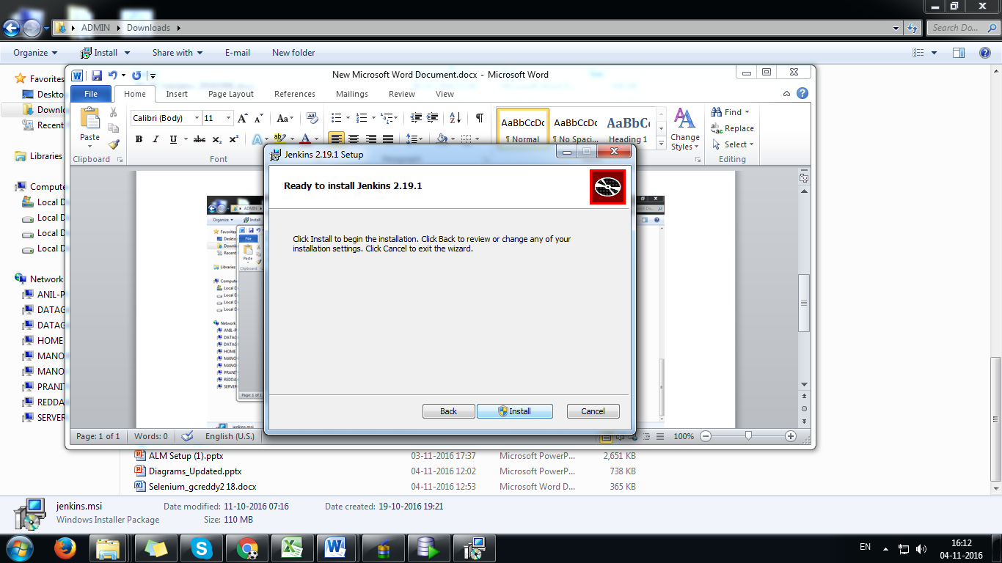

After finish the installation it will show finish button. Click on finish button.
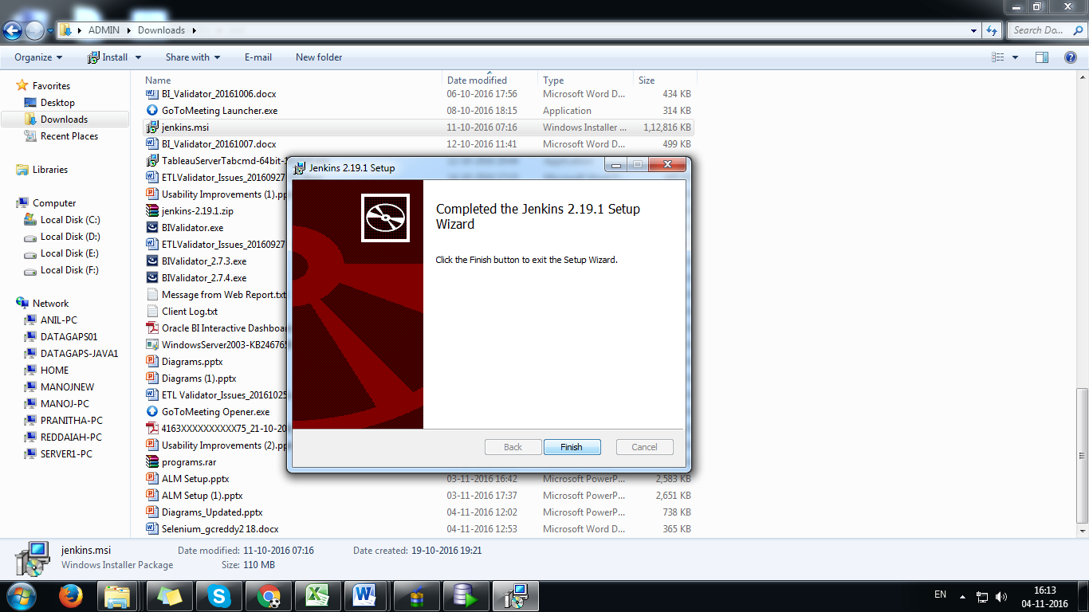

Once you click on finish button will redirect you into browser and show you jenkins ready status.
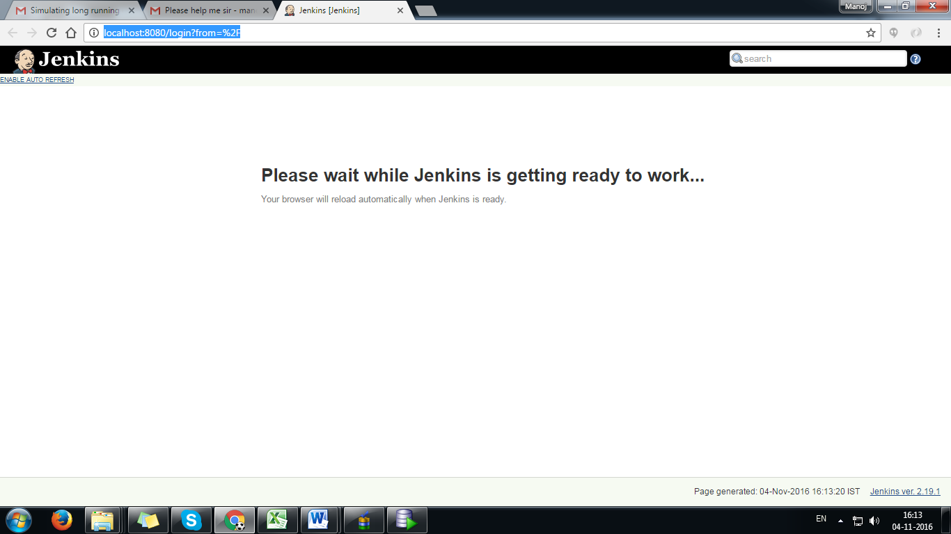

Once jenkins is ready to work then it will ask you "Administrator Password" to open jenkins home page.
Bellow screen show you where the password is available.
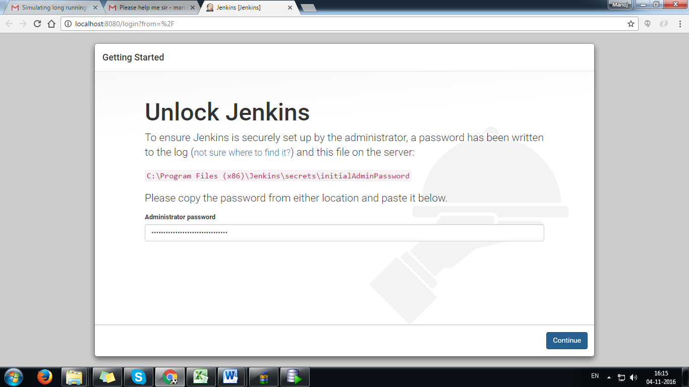

After enter the password it will open Customize Jenkins page and ask you to select "install suggested plugins" for the download all suggested plugins. If you want to select plugins whatever you want you can select "select plugins to install".
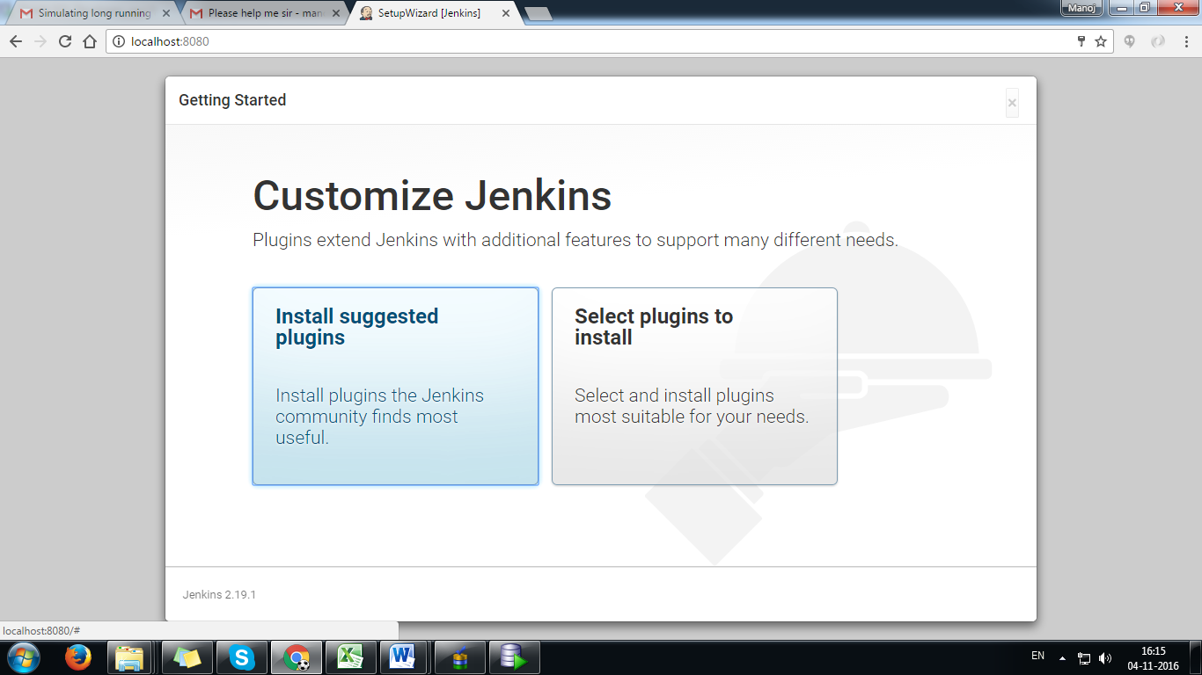

After select the plugins click on install button.
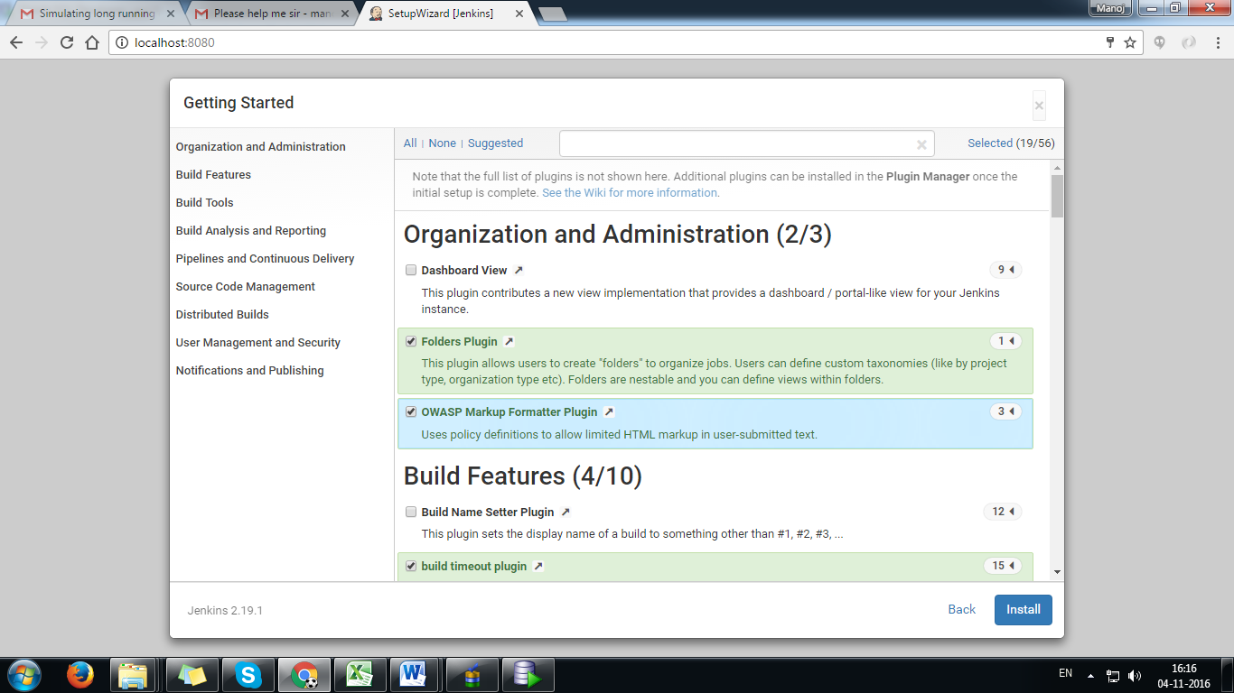

Here it will show you list of downloading plugins.
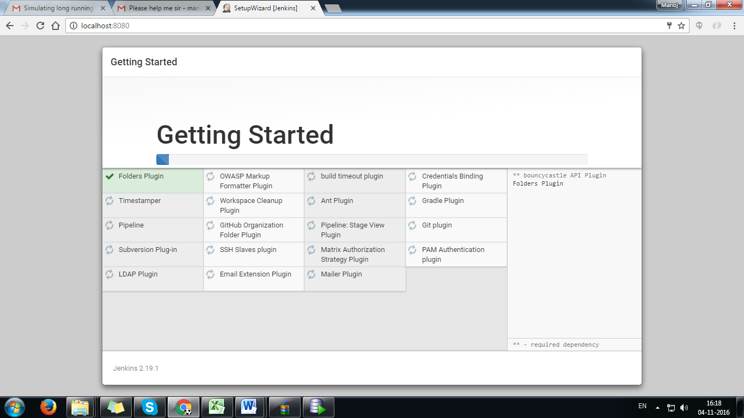

After finish the downloading plugins it will ask you to create first admin user.
Enter the details and click on "Save and Finish" button.
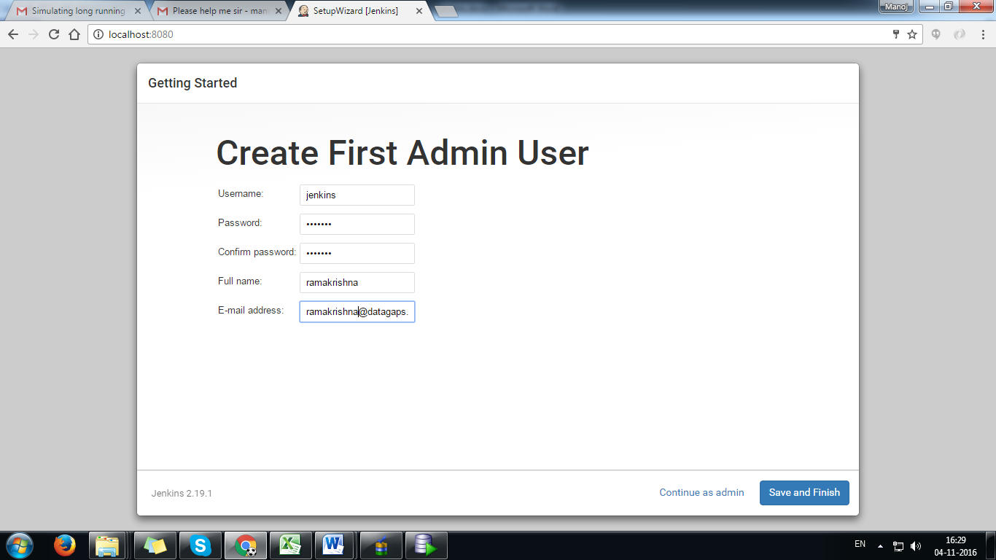

After finish the jenkins setup it will show you "jenkins ready page". Click on "start using jenkins" button.
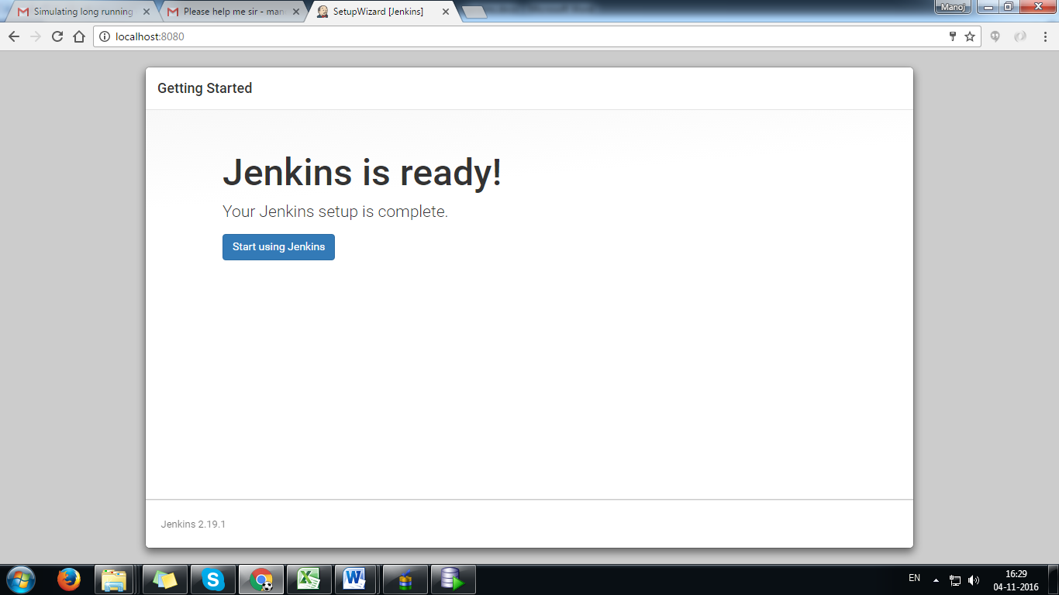

Now jenkins home page is ready. (after installation Jenkins is available on its default port: http://localhost:8080/)
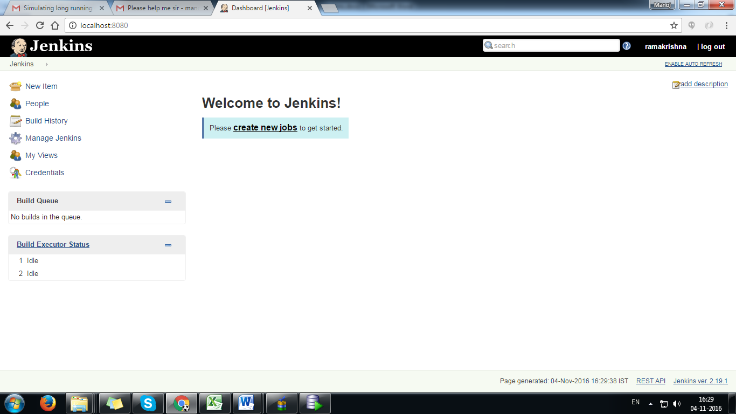

Configure DGCL on Jenkins

Here we will show you how to setup DGCL build with jenkins that automatically executes your test plans, test cases and get status of test plans, test cases and display the results on jenkins console.

Step - 1: Add new Job Go to the Jenkins dashboard and Click on New Item
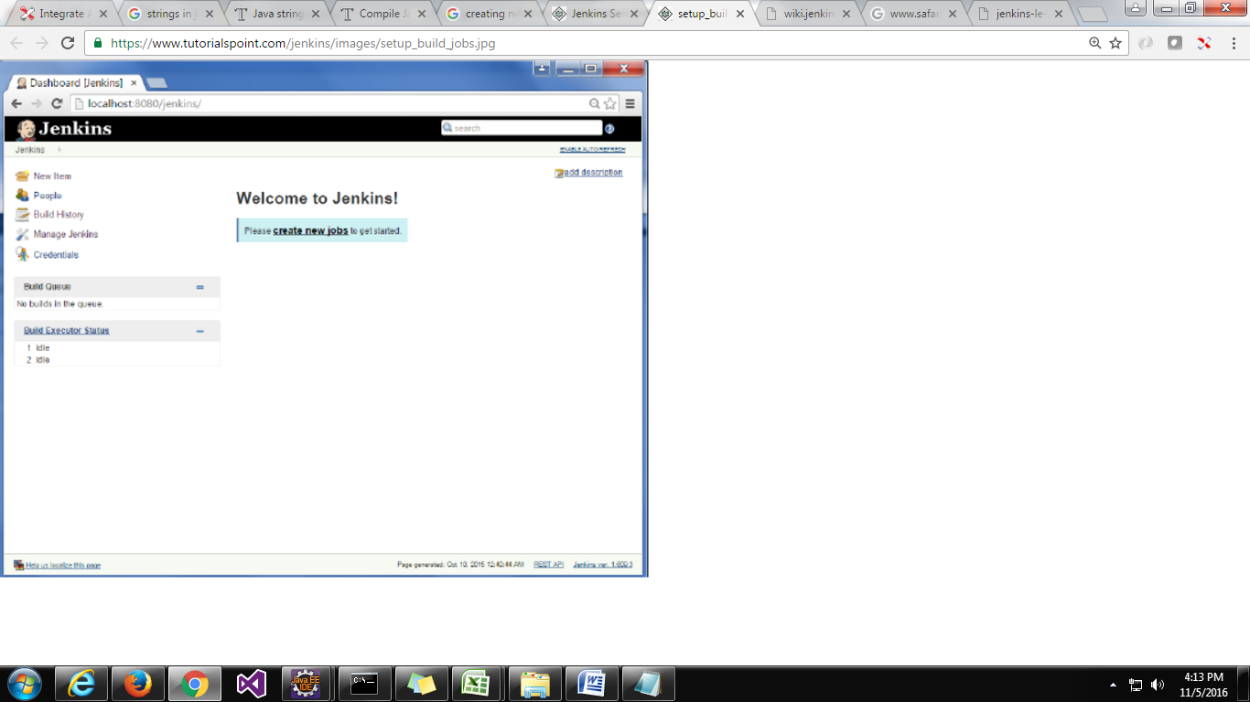

Step 2 − In the next screen, enter the Item name, in this case we have named it DGCL-Test. Choose the "Freestyle project" option and click "Ok" button.
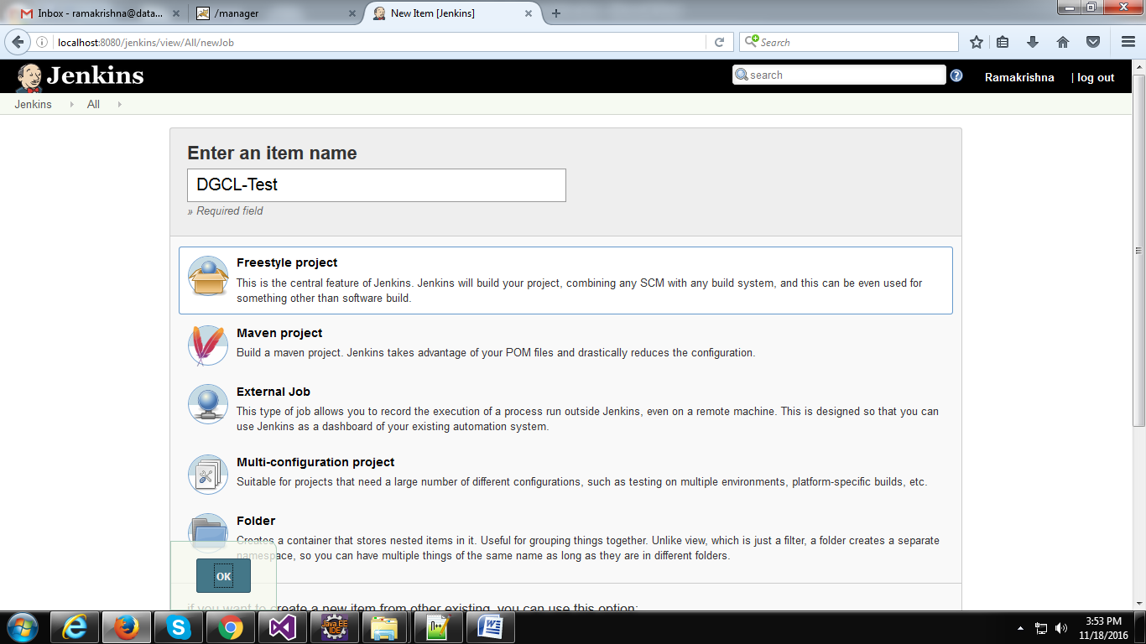
Step 3 − The following screen will come up in which you can specify the details of the job.
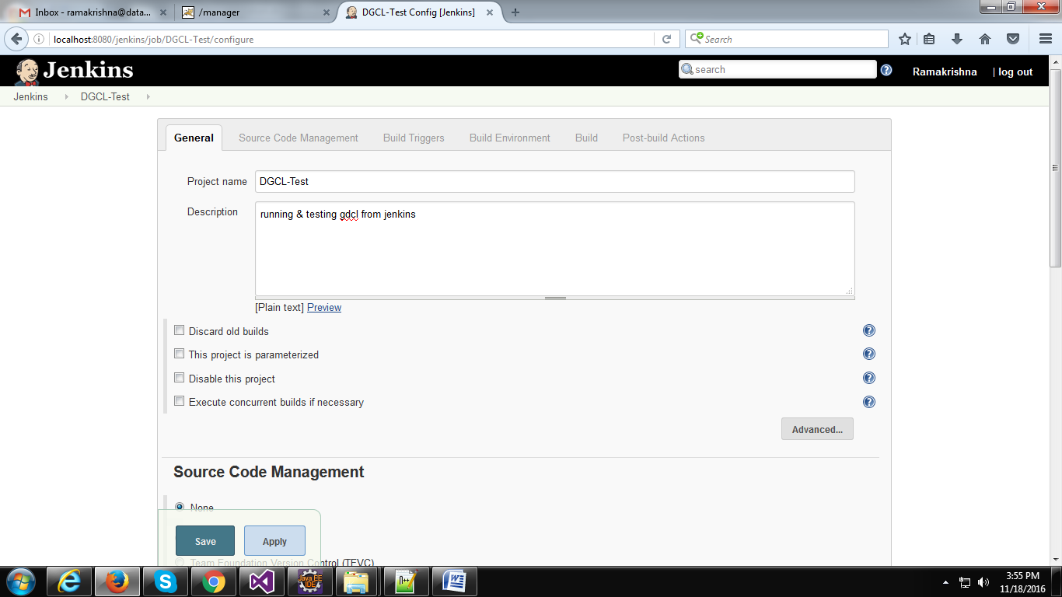
In the description you enter project details to understand. And keep the all check box's uncheck for now.

Step 4- Configure Source Code Management
We need to specify the location of the files which need to be built.

a). If project files on Local system
If you have build in your local system then you can skip this step and click on apply and save.
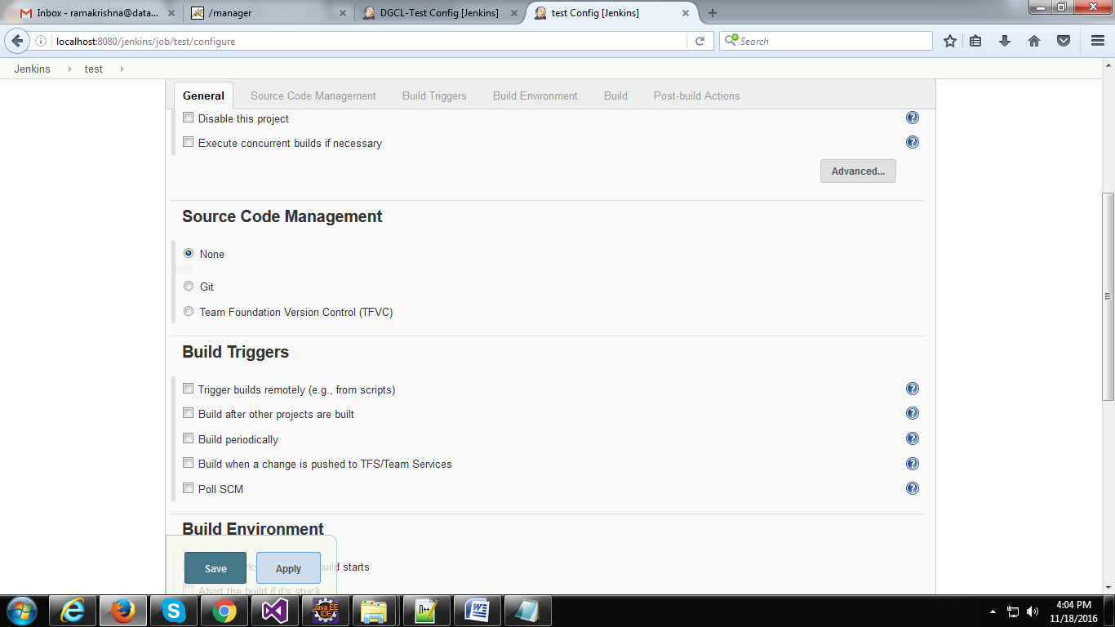
Keep default selection None.
b). If project files on TFS
Start with choosing Team Foundation Version Control (TFVC) as source code management tool.
Enter the following details.
Collection url: https://datagaps.visualstudio.com
project Path: $/Datagaps/ETLValidator/DGCL_build
Credentials: for credentials select "manual" from the drop down and enter the TFS credentials. (Here we should enter "Alternate authentication credentials" to connect to TFS and check out the code)
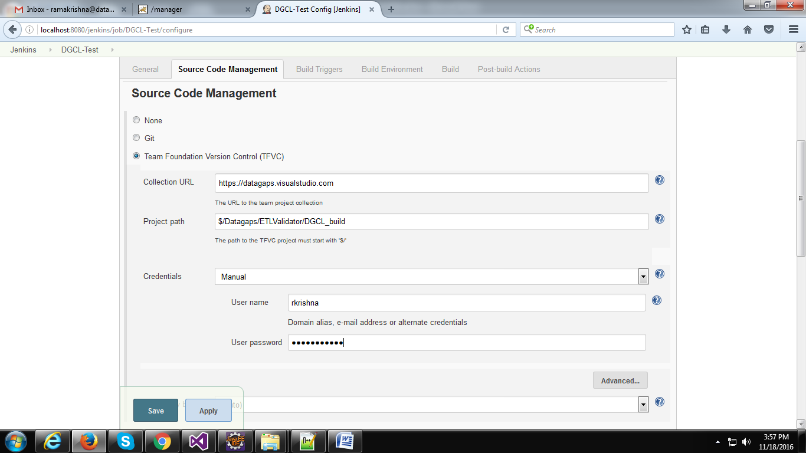

Step 5 − Once saved, you can click on the Build Now option to see if you have successfully defined the job.
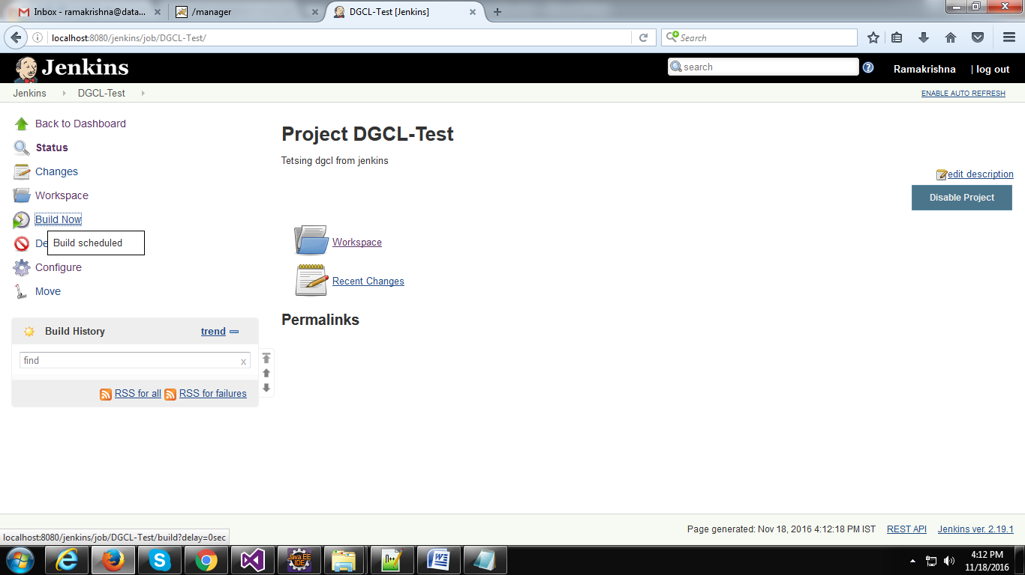
Step 6 − Once the build is scheduled, it will run. The following Build history section shows that a build is in progress.
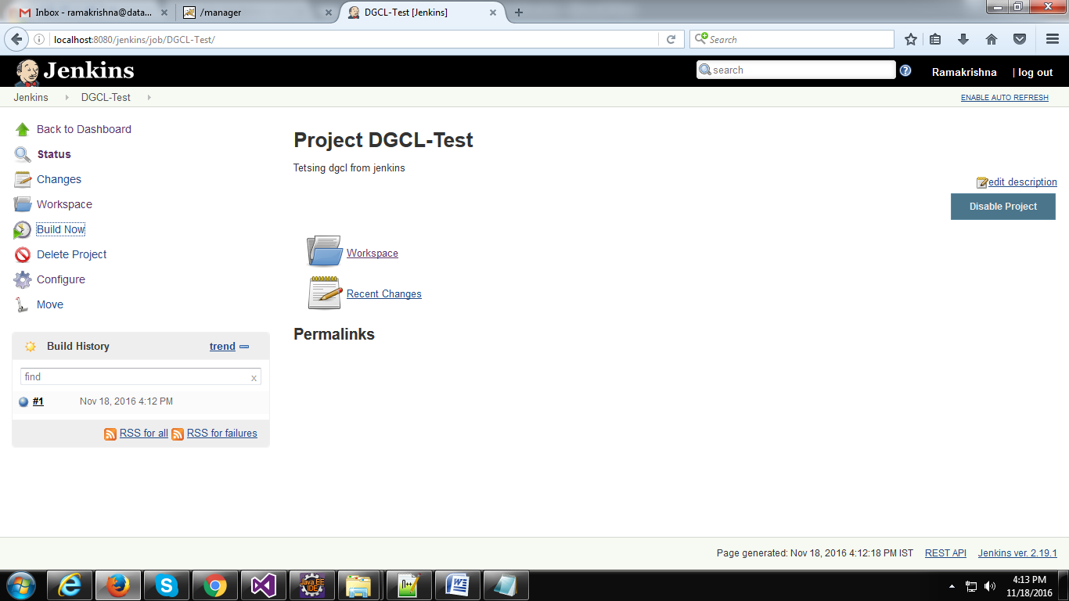

Once build run is successfully completed, then it will create a folder with the project name(DGCL-Test) in jenkins home folder under workspace.
If you select "TFVC" under source code management then it will check out the project files from TFS andautomatically save into your jenkins workspace. You can check the downloaded files bellow folder.
jenkinsHomeDir(C:\Users\DATAGAPS\.jenkins)>> workspace>>DGCL-Test.

If you select "None" under source code management then it will create empty folder in your jenkins workspace.
jenkinsHomeDir(C:\Users\DATAGAPS\.jenkins)>> workspace>>DGCL-Test.
Now you copy the files lib and dgcl.jar from your local system and paste it into above folder.

Step 7 - Now back to jenkins and go to project home page now click on configure tab from the left side menu.
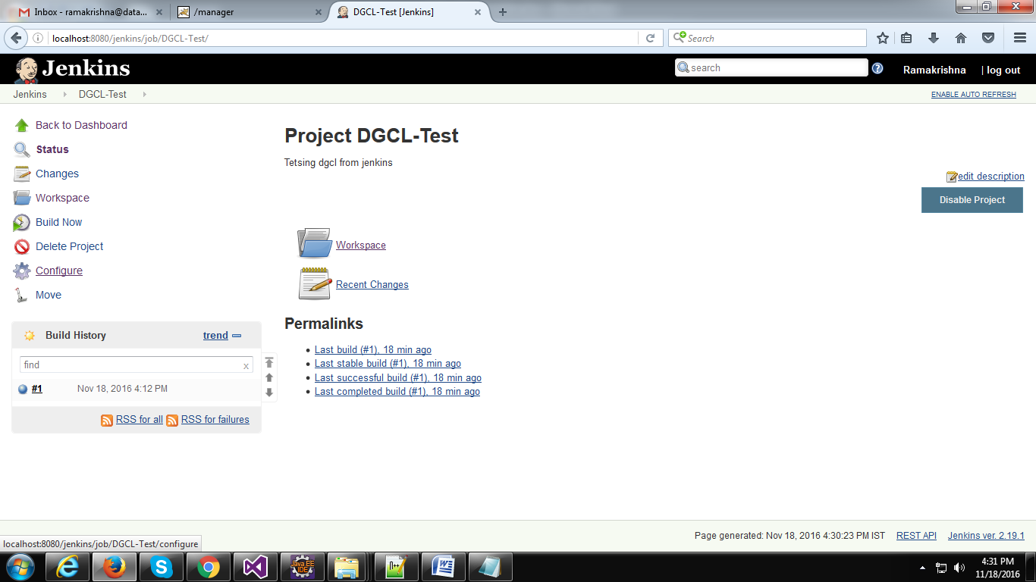
Step 8 - Now go to the build section and select "Execute windows batch command" from the dropdown.
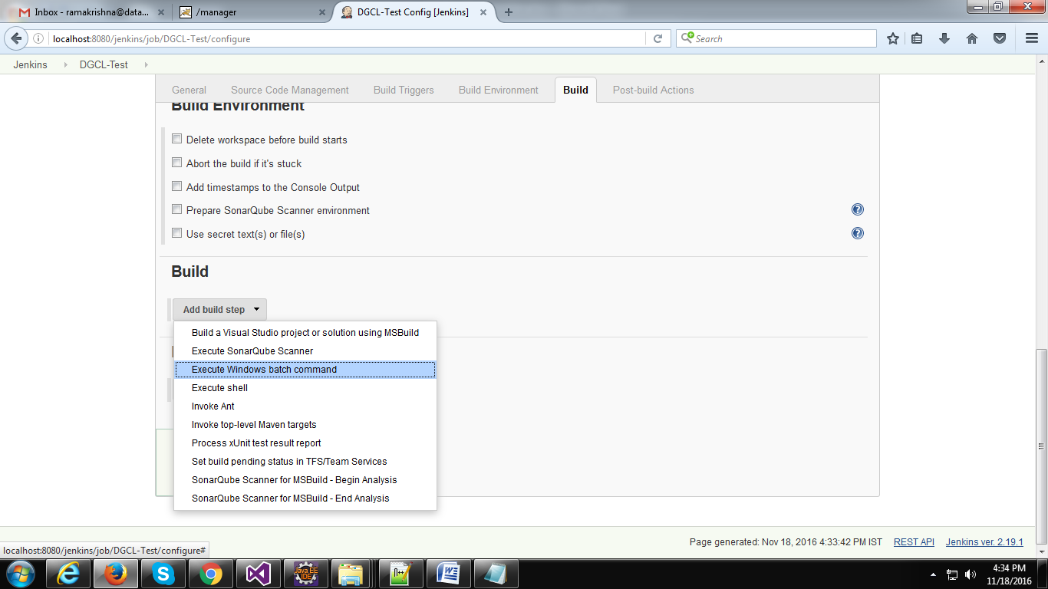

Step 9 - Now eneter the command line scripts in the Command box to run test paln/case and get test plan/case status and some other.
Ex: sample command to get the testcase status.
java -jar dgcl.jar -GetTestCaseStatusById -id 40604 -url "http://localhost:8080/ETLValidatorServer/Execute?wsdl"
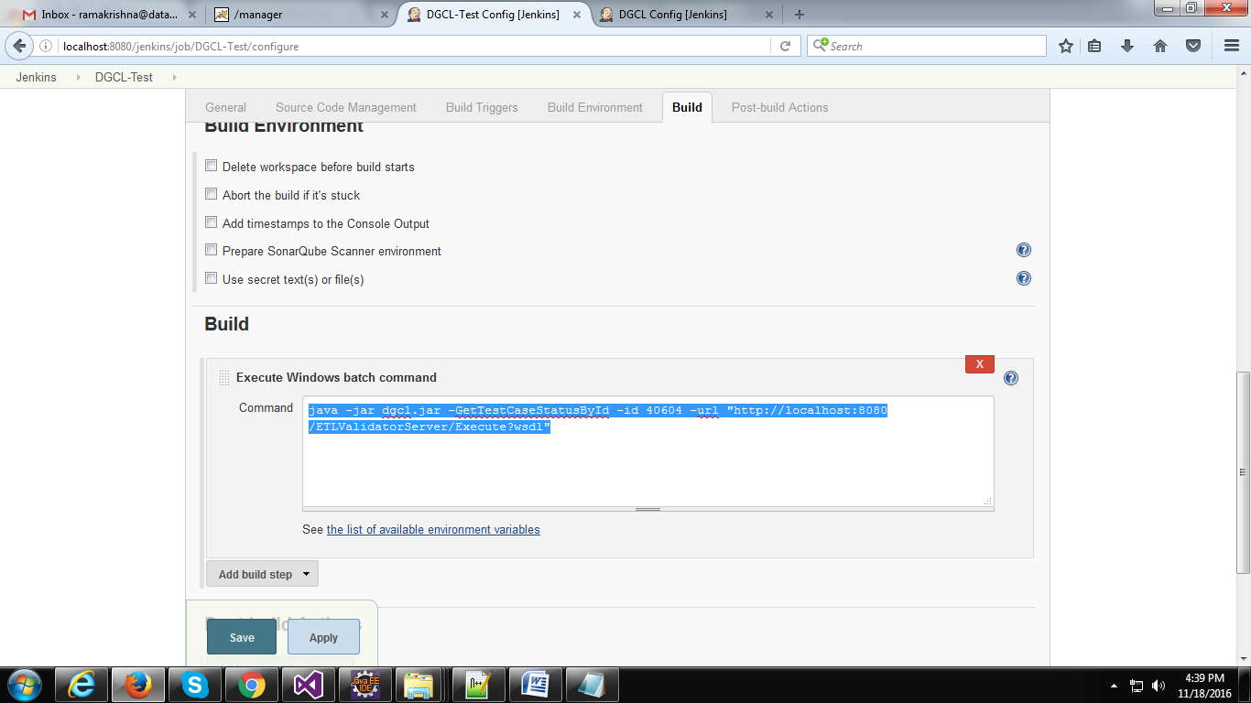

If you want to execute mutliple commands in the same build you can add all commands into the above Command box by seperating with enter key.
Sample commands:
To get the testcase status.
java -jar dgcl.jar -GetTestCaseStatusById -id 40604 -url "http://localhost:8080/ETLValidatorServer/Execute?wsdl"
To run the test plan By Id
java -jar dgcl.jar -RunTestPlanById -id 2283 -p admin -u admin -url "http://localhost:8080/ETLValidatorServer/Execute?wsdl"
To run the test case By Id
java -jar dgcl.jar -RunTestCaseById -id 40544 -p admin -u admin -url "http://localhost:8080/ETLValidatorServer/Execute?wsdl"
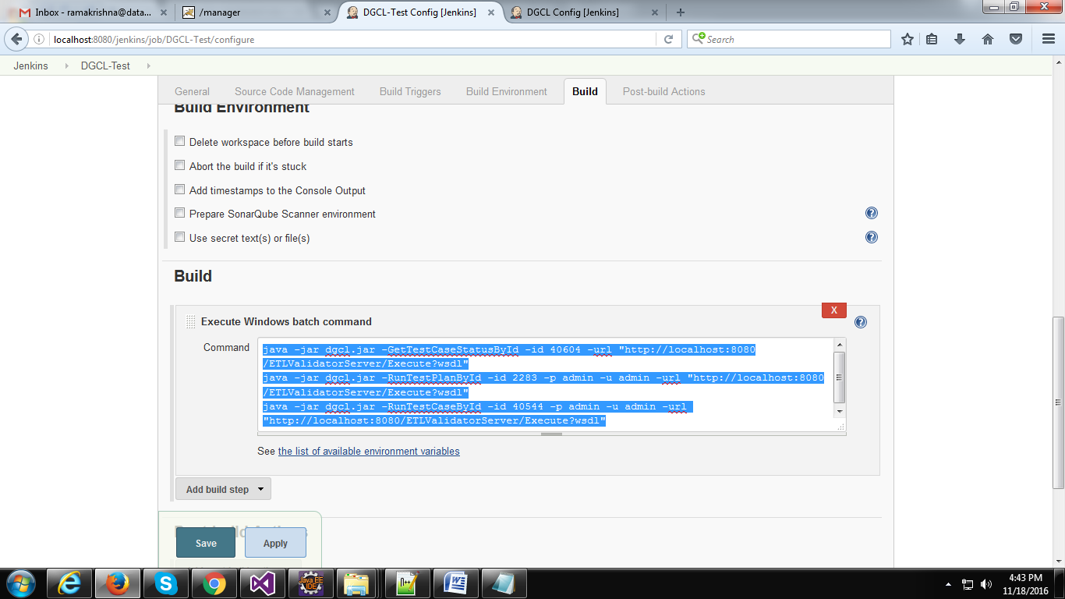
Now click on apply & Save.

Step 10 − Once saved, you can click on the Build Now option to see if you have successfully defined the job.
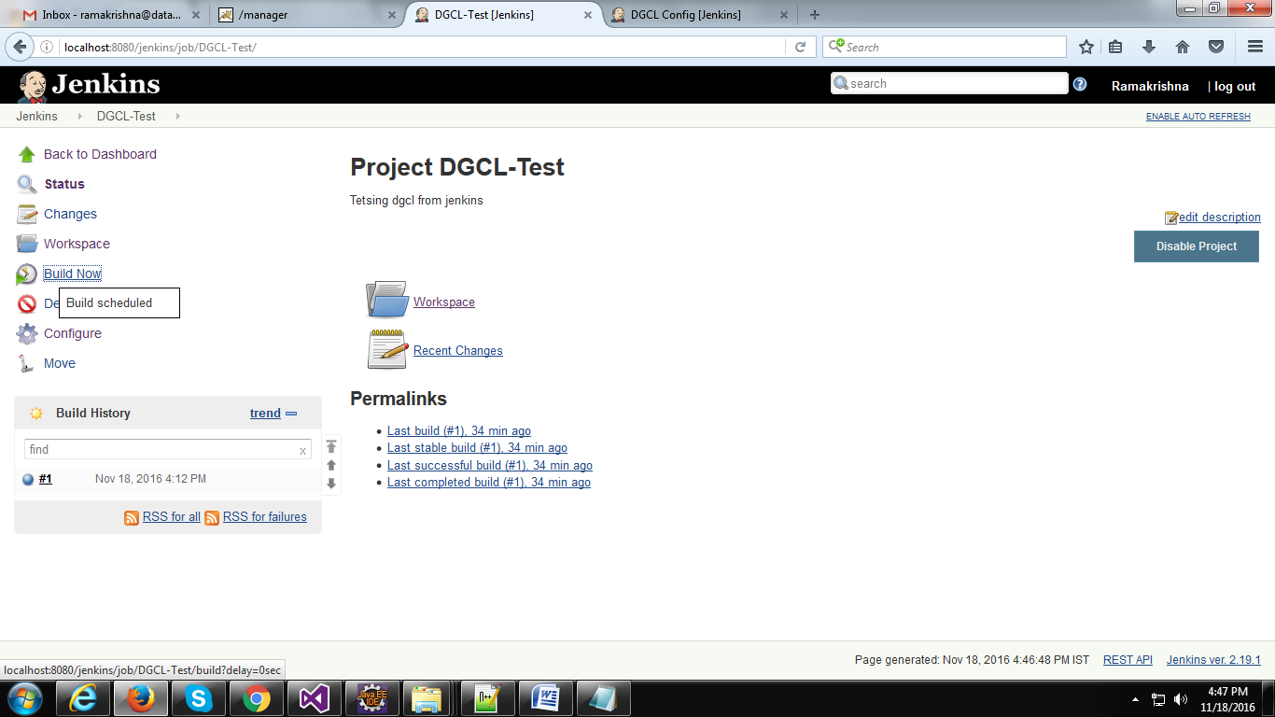
Step 11 − Once the build is completed, a status of the build will show if the build was successful or not. In our case, the following build has been executed successfully.
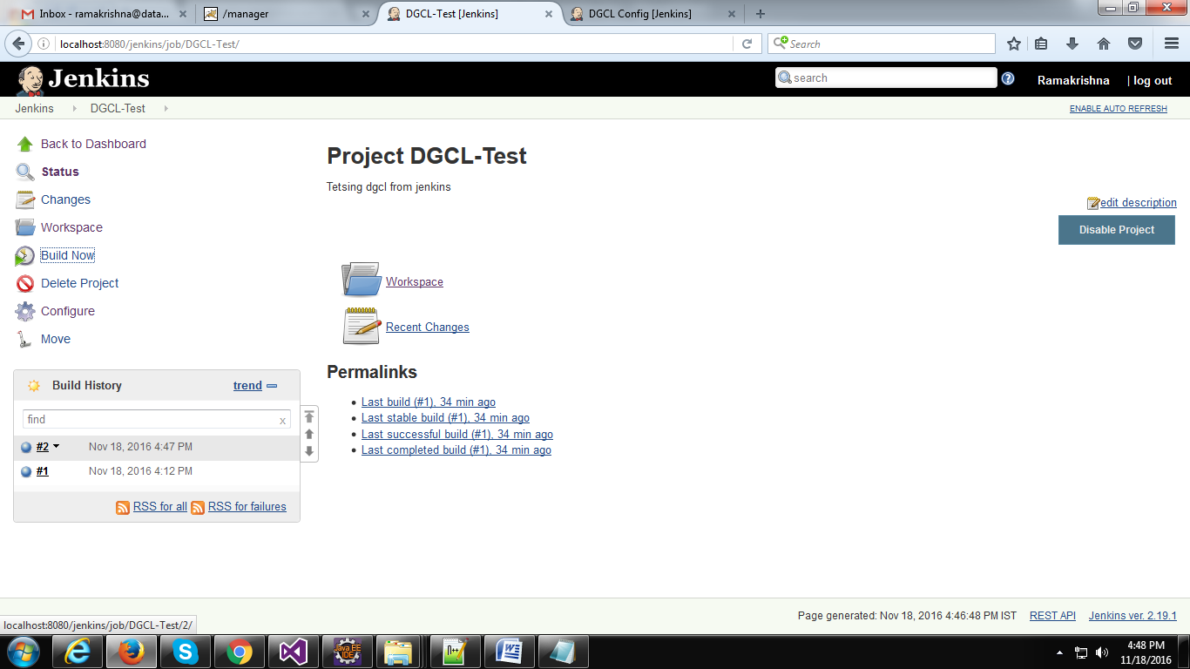

Step 12 − Click on the #2 in the Build history to bring up the details of the build.
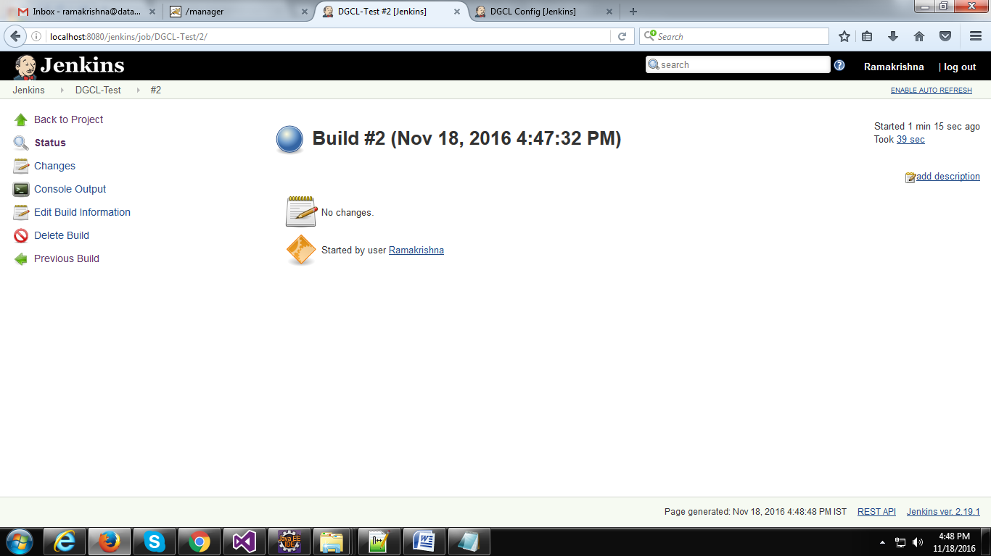

Click the "Console Output" Tab from the left side menu to see the console output.
