ETL Validator Hardware Requirements & Architecture

Prepared by

datagaps

http://www.datagaps.com

http://help.datagaps.com

http://datagaps.freshdesk.com
Contact
contact@datagaps.com

Table of Contents
Purpose of the DOCUMENT 1
ETL Validator 2
ETL Validator Architecture 2
ETL Validator Client 2
ETL Validator Server 2
Repository and Work Schema (Database Users) 3

Purpose of the DOCUMENT
This document explains the architecture, hardware requirements and pre-requisites for deploying ETL Validator.

ETL Validator

ETL Validator Architecture
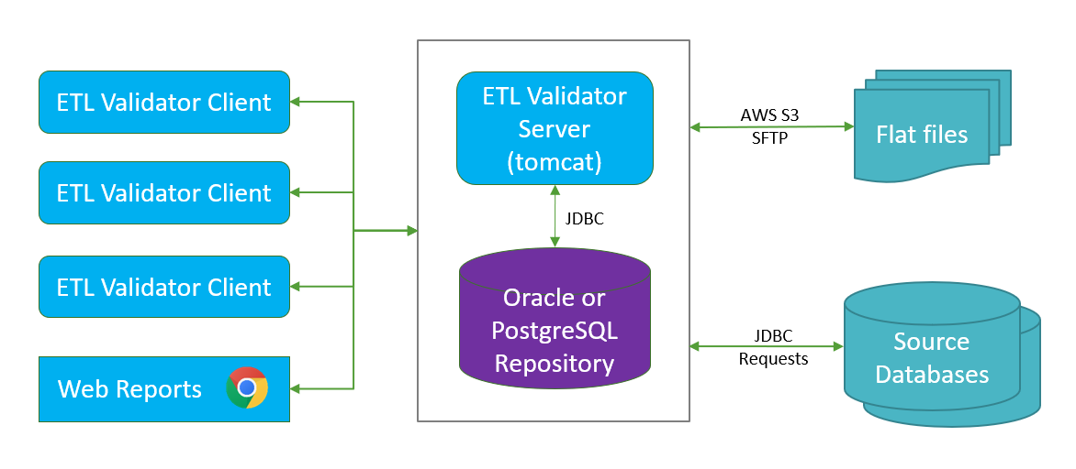

ETL Validator Client
ETL Validator Client is Windows based thick client software.
- Operating System
  - Windows 10, Windows 2012 or later
- Hardware
  - Processor
    - Minimum: 4 Cores
    - Recommended: 8 Cores
  - Memory (RAM)
    - Minimum: 8 GB
    - Recommended: 16 GB or more
  - Hard drive
    - Minimum: 10 GB of free hard-disk space for program installation and operation
  - Display Resolution:
    - Minimum: 1366x768
    - Recommended: 1920x1080

ETL Validator Server
ETL Validator's server consists of Reporting and Server archive files that can be deployed on Apache Tomcat and PostgreSQL database
- Software
  - Java 1.8 (comes bundled with ETL Validator Complete)
  - Tomcat 9 or later (comes bundled with ETL Validator Complete)
  - PostgreSQL 10.x or Oracle 12c/18c/19c as Repository/Workschema
- Operating System
  - Linux or Windows Operating System
- Hardware
  - Processor
    - Minimum: 8 Cores
    - Recommended: 16 Cores or better
  - Memory (RAM)
    - Minimum: 16 GB RAM
    - Recommended: 64 GB (ECC) or more
  - Hard Disk
    - Minimum: 500 GB SSD
    - Recommended: RAID. Size is dependent on the volume of data being tested. Typically, the size needed is 2.5 times the volume of data being compared.
  - Network
    - Minimum: 1 Gb
    - Recommended: 10 Gb

Repository and Work Schema (Database Users)
PostgreSQL: Repository and Workschema databases come out of the box as part of ETL Validator Complete.
Oracle: Two oracle users (one for repository and the other for workschema) should be created. Details on the users and their permissions can be found in the knowledge base post below:
http://datagaps.freshdesk.com/support/solutions/articles/1000155087-oracle-repository-and-workschema-requirements

